MULTAN ELECTRIC POWER COMPANY (MEPCO)



POWER DISTRIBUTION ENHANCEMENT INVESTMENT PROGRAM - MULTI TRANCHE FINANCING FACILITY, UNDER ASIAN DEVELOPMENT BAKN (TRANCHE - II)

UPDATE OF LARPs
(ALIPUR, FATEHPUR & MIRANPUR)
(APRIL, 2013)

CHIEF ENGINEER (DEVELOPMENT) PMU MEPCO MULTAN
- INTRODUCTION AND BASIC DATA
MEPCO has exclusive service territory; the biggest one with largest network spread over 13 administrative districts of the southern Punjab i.e. Multan, D.G Khan, Muzaffar Garh, Vehari, Bahawal Pur, R.Y. Khan, Sahiwal, Bahawalnagar, Lodhran, Khanewal, Pak Pattan, Layyah and Rajan Pur.
The transmission and distribution net work of the company is highly inadequate characterized by low voltage and high losses and unable to meet the future load demand and needs to be re-enforced. The company has to invest in the system for expansion and augmentation to address issues pertaining to capacity reliability and cost of electricity. The company has prepared a five years investment program which stands approved by GoP.
Since MEPCO is unable to meet the capital investment to the development program. it was decided to approach the loaning agencies through Government of Pakistan like Word Bank, ADB and other financing sources to arrange financing. Negotiations were carried out with the Asian Development Bank and the bank has agreed to support the program through Multi Tranche Financing Facility-1 (MFF-1) to be implemented in three phases i.e. Tranche-I, II & III.

- Land Acquisition and Resettlement Plans (LARPs)

The LARPs are project specific documents and concerns those projects in which land acquisition is involved. M/S BPI, the Consultant for Power Distribution Enhancement Investment Programm Under Asian Development bank (Tranche – II), have prepared Land Acquisition and Resettlement Plans (LARPs) as per LARF and ADB safeguard policy guidelines for those MEPCO sub-projects which fall in LARP requirement Category. These LARP documents have been prepared on behalf of MEPCO by M/S BPI.
Land Acquisition Resettlement Plan has been prepared for Miranpur Galleywal (New frid station), Alipur and Fatehpur transmission lines sub projects for Tranche – II subprojects.
C. PROVISION OF COMPENSATION TO THE AFFECTED PERSONS
Land acquisition tasks under the Tranche-II for MEPCO subproject involving compensation is being implemented according to a compensation eligibility and entitlements framework in line with both the Pakistan’s law/regulation and ADB Policy.
A summary entitlements matrix is provided in Table below.
Table – 1. Compensation Eligibility and Entitlements Matrix
Asset | Specification | Affected People | Compensation Entitlements
Land permanently acquired for sub-station | 1. Donated/bought on the open market  2. Acquired via right of eminent domain | Land owners | If donated or voluntarily sold ADB Policy is not triggered  If acquired via exercise of the right of eminent domain land will be compensated at fill market value.
Arable Land temporarily affected by construction of towers or TL. | Access is not restricted and existing or current land use will remain unchanged by the construction of towers and transmission line | Farmer,  Titleholder | No land compensation provided that land is rehabilitated/restored to former quality following completion of works. Compensation, in cash, for all damaged crops and trees as per item below
 |  | Leaseholder  (registered or not) | No land compensation provided that the land is rehabilitated/restored to former quality following completion of works. Compensation, in cash, for all damaged crops and trees as per item below
 |  | Sharecroppers  (registered or not) | Compensation, in cash or kind, for all damaged crops/trees as per item below
 |  | Squatters | Compensation, in cash, for all damaged crops/trees as per item below
Arable Land where tower/TL construction restricts access or agricultural use. | All adverse effects on land use independent of severity of impact | Farmer,  Titleholder | Land for land compensation with plots of equal value and productivity to the plots lost; or cash for affected land at replacement cost based on market value plus 15% compulsory acquisition surcharge and free of taxes, registration, and transfer costs
 |  | Leaseholder  (registered or not) | Renewal of lease in plots of equal value/productivity of plots lost, or Cash equivalent to market value of gross yield of affected land for the remaining lease years (up to a maximum of 3 years).
 |  | Sharecroppers  (registered or not) | Cash compensation equal to market value of lost harvest share once (temporary impact) or twice (permanent impact)
 |  | Agricultural workers | Cash indemnity equal to salary (including portions in kind) for remaining part of agricultural year.
 |  | Squatters | 1 rehabilitation allowance equal to market value of 1 gross harvest (additional to crop compensation) for land use loss.
 | Additional for severe impacts  (>10% of land loss) | Farmer,  Titleholder  Leaseholder | 1 severe impact allowance equal to market value of gross harvest of affected land for 1 year (inclusive of winter and summer crop and additional to standard crop compensation)
 | Additional for severe impacts  (>10% of land loss) | Sharecroppers  (registered or not) | 1 severe impact allowance equal to market value of harvest share (additional to standard crop compensation)
 |  | Squatters | 1 severe impact allowance equal to market value of gross harvest of the affected land for 1 year (inclusive of winter and summer crops and additional to standard crop compensation)
Residential/  Commercial  Land affected by towers/ TL | Future usage of the land will get restricted permanently | Titleholder | Land for land through provision of plots comparable in value/location to plot lost; or cash for affected land at full replacement cost free of taxes, registration, transfer costs plus 15% compulsory acquisition surcharge.
Residential/  Commercial  Land affected by towers/ TL | Future usage of the land will get restricted permanently | Renter, Leaseholder | 1-3 months allowance based on current monthly rent
Residential/  Commercial  Land affected by towers/ TL | Future usage of the land will get restricted permanently | Squatters | Relocation in a public resettlement area or a self-relocation allowance
Houses and  Structures | Affected houses /structures will be demolished | Relevant AHs/ squatters | Cash compensation at replacement rate for affected structure/other fixed assets free of salvaged materials, depreciation or transaction costs. For partial impacts full cash assistance to restore remaining structure.
Crops | Crops affected (damaged/lost) | All AHs/ squatters | Tower impacts: Cash compensation at market rate based on actual impact for a maximum of 3 harvests for this subproject 1 harvest is expected to be sufficient)  Line corridor stringing: cash compensation at market rate of 1 harvest.
Trees | Trees removed | All AHs/ squatters | Cash compensation shall reflect income replacement
Business  Employment | loss of business or employment | All AH/ squatters | Owner: (i) Cash compensation equal to 1 year income, if loss permanent; (ii) cash compensation for the period of business interruption, if loss is temporary. Worker/employee: lost wages indemnity for the business interruption period up to a 3 months maximum.
Relocation | Transport,  transition costs | All AHs so affected | Provision of sufficient allowance to cover transport expenses and livelihood expenses for one month.
Community | structures & installations | Concerned community | Rehabilitation/substitution of affected structures/utilities (i.e. mosques, roads, schools etc.
Vulnerable AH |  | AH below poverty | Employment priority in project-related jobs.

Eligibility
The AHs entitled to compensation and/or rehabilitation under the program are:
- All Ahs affected by restricted access to, or use of, land whether they have legal title/traditional land rights or not.
- Tenants and sharecroppers whether registered or not.
- Owners of buildings, crops, land, plants, or other objects attached to the land; and Ahs losing business, income, and salaries.
Compensation eligibility will be limited by a cut-off-date to be set for each subproject on the stating day of the AH census and impact assessment. AHs who settle in the affected areas the cut-off-date will not be eligible for compensation. They will, however be given sufficient advance notice, requested to vacate premises and dismantle affected structures prior to project implementation. Their dismantled structures will not be confiscated and they will not pay any fine or sanction. Forced eviction will only be considered all other efforts are exhausted.

Cut-off Date:
Compensation eligibility is limited by a cut-off-date, fixed by BPI for MEPCO is 20th September 2008 for Alipur, Fatehpur and Miranpur (Galleywal) subprojects, which were the last day of the affected households census and Impact Assesment Fieldwork. AHs that settle in the affected areas and/or make changes in the land use patterns this cut-off-date is not be eligible for compensation. They will, however, be given sufficient advance notice requesting them to vacate premises/corridor and dismantle affected structures and/or other establishments (if any) prior to project implementation.
Revision in Rates of Compensation
As rates of the crops has been increased and since no project has been executed and payments has not been made to the Affected Persons. ADB vide Email dated: 12.03.2013 has emphasized MEPCO and others DISCOs to update Land Acquisition & Resettlement Plan (LARP) therefore latest rates of the affected crops have been incorporated in LARPs.
These reports /plans have been prepared as per LARF Guiedlines and briefly summarizes (according to old rates) as under subprojects.
Alipur up gradation and construction of about 11.33 km, 132 kV D/C, I/O arrangement from 132 kV Jatoi – Khair Pur Sadat (length not mentioned).
Impact: As per report area total affected area is 355650m² of crops and 421 trees (372 fruit trees and 49 wood trees), but no built-up structures and a total of 62 farming households (AHs) with a population of 549 persons (APs) involving compensation Rs.21,229,472/-
Fatehpur up gradation and construction of about 2.67 km, 132 kV D/C, I/O arrangement from 132 kV Chowk Azam – Bhakkar (length not mentioned).
Impact: As per report sub project is contained in two (02) villages and will affect total area of 89120m² of crops and 178 trees (174 wood trees and 4 fruit trees) and 15 affected households (AHs) with a total population of 151 (APs) involving compensation of Rs.7,257,340/-.
Miranpur new Grid Station with 11.39 KM long, 132 kV D/C, I/O arrangement feed from 132 kV Multan – Bahawalpur (length not mentioned).
Impact: As per report sub project is contained in four (04) villages and will affect 71 farming households (AHs) with a population of 689 persons and total area of crop 357,687m² of crops and 122 wood trees involving compensation Rs. 17,634,511/-.
Kameer new Grid Station with only 60m long, 132 kV arrangement feed from 132 kV Yousafwala – Arifwala double circuit transmission line.
Impact: According to DDR submitted by BPI, there is neither any structure nor any crops or tree being affected by this subproject but there is one tubewell which will be affected and for which MEPCO has already agreed to pay the replacement value and is included in sale deed. A total of 49 kanals and 8 marals land is being purchased on willing seller – willing buyer basis. Cost of land and tubewell replacement value is total of Rs. 6,446,738/- .
Noorsar Grid Station: Conversion from 66kV to 132 kV arrangement feed from 132 kV Bahawalnagar – Chistian transmission line at tower no.104.
Impact: According to DDR submitted by BPI, there is no private land, crops or any other structure is involved and there is no claim by anyone on grid station land that is why there is no compensation involved in this subproject as all the activities shall remain within the boundary of grid stations.
Complete detail of compensation and rates is enclosed at Annex [C]
Summary of the LARPs (collectively) Annex [D]
No. | Resettlement Activity | No. | Unit | Rs./Unit | Total Rs.
A. | Asset Compensation: | - | - | - | 28,249,882
A.1 | Land  (Miranpur+Kameer Grid Stations) | 11.895 | Acre | - | 6,435,000
A.2 | Trees: | 721 | tree | - | 7,901,600
A.3 | Crops: | 802,457 | m² | - | 7,773,532
B. | Technical Assistance: | - | - | - | 9,050,000
C. | Rehabilitation Works: | 369,150 | m² |  | 316,613
D. | Administration Costs (15% of A) | 0.15 | lumpsum | 28,249,882 | 4,237,482
E. | Subtotal (A+B+C+D) | - | - | - | 41,853,977
F. | Contingency (10% of D) | 0.1 | lumpsum | 41,853,977 | 4,492,386
Total Amount (Pak. Rupees): |  | - | - | - | 46,346,363
Total Amount (US Dollars*): |  | - | - | - | 588,152
* US$ 1.00 = Rs. 78.80.
Total of Rupees Forty Six Million Three Hundred Forty Six Thousand Three Hundred Sixty Three Rupees (46,346,363/-)

Now as per instruction of ADB, compensation amount rates for affected crops, trees, administration cost, contingencies has been updated to current market rates and summary of these are as under.
- Ali Pur = Rs. 21,229,472 Annex [E]
- Fatehpur = Rs. 7,257,340 Annex [F]
- Miranpur (Galleywal) = Rs. 17634,511 (Excluding purchase of Land) Annex[G]
Summary of the LARPs (collectively according to updated rates) Annex [H]
No. | Resettlement Activity | No. | Unit | Rs./Unit | Total Rs.
A. | Asset Compensation: | - | - | - | 33,228,585
A.1 | Land  (Miranpur+Kameer Grid Stations) | 11.895 | Acre | - | 12,881,738
A.2 | Trees: | 721 | tree | - | 8,998,750
A.3 | Crops: | 802,457 | m² | - | 11,348,097
B. | Technical Assistance: | - | - | - | 9,050,000
C. | Rehabilitation Works: | 369,150 | m² |  | 316,613
D. | Administration Costs (15% of A) | 0.15 | lumpsum | 28,249,882 | 4,984,287
E. | Subtotal (A+B+C+D) | - | - | - | 47,579,485
F. | Contingency (10% of D) | 0.1 | lumpsum | 41,853,977 | 47,579,48.5
Total Amount (Pak. Rupees): |  | - | - | - | 52,337,433
Total Amount (US Dollars*) |  | - | - | - | 528,394
* US$ 1.00 = Rs. 99.05.
Total Of Rupees Fifty Two Million Three Hundred Thirty Seven Thousand And Three Hundred Forty Three Rupees(52,337,433/-)

Now the (Rs. 52,337,433/- Total amount of fifty two million three hundred thirty seven thousand and four hundred thirty three (including purchases of land for Miranpur& Kameer) against previous (Rs 46,346,363/-) total amount of forty six million three hundred forty six and three hundred sixty three rupees only according to new rates is under approval by the competent authority of MEPCO for the provision of compensation to the Affected Persons.
Assessment of Compensation Unit Values
The methodology for assessing unit compensation values of different items is as follows:
- Land valued at replacement cost based on land sales survey during the year before the impact survey. No deductions for taxes/transaction cost are applied.
- Housing/ Buildings are valued at replacement value based on cost of material, type of construction, labor, transport and other construction cost. No deductions are applied for depreciation, salvaged materials and transaction cost.
- Annual crops are valued at net market rates at the farm gate for the first year crop. In the eventuality that more than one year compensation is due to the Ahs the crops after the first will be compensated at gross market value.
- Fruit tree are valued basede on age category (a. Seedling; b. Not yet productive; c. Productive). Productive trees are valued at gross market valued of one year income multiplied by the number of years needed to grow a new tree with the productive potential of the lost tree.
D- LARP PRE-REQUISITE FOR SUB-PROJECTS (ALIPUR, FATEHPUR & MIRANPUR)
ACTIVITY | STATUS
GRIEVANCE REDRESSAL COMMITTEE | CRC already notified for World Bank subprojects shall also be available for Grievance Redressal in ADB funded projects and process of grievance redressal has also be approved by the competent authority. Annex [J&K]
INTERNAL MONITORING MECHANISM & ENVIRONMENTAL SOCIAL COMPLAINT REGISTER | Environmental & Social complaint registers and complaint procedures have been prepared both in Urdu and English in order to facilitate the project affectees and stakeholders to register their complaints Annex [L&M]. Internal Monitoring Mechanism have been prepared and PD(GSC) has been asked to nominate Environmental & Social Inspecters (ESIs) and Environmental Social Monitors (ESMs) to ensure the effective internal monitoring.
66 KV TO 132KV ALIPUR GRID STATION | There is no need to of purchase of additional land for this subproject but for the line subproject compensation shall be provided to the affected persons for loss of their assets, trees or crops etc.
66 KV TO 132KV FATEHPUR GRID STATION | There is no need to of purchase of additional land for this subproject but for the line subproject compensation shall be provided to the affected persons for loss of their assets, trees or crops etc.
NEW 132 KV MIRANPUR +KAMEER (SUBPROJECT) | - Purchase of land for new grid station (Miranpur, galleywal) has been made purely on willing –seller and will-buyer basis.  - Total 5.72 acres land has been purchased at total agreed amount of Rs. 6,435,000/- exclusive of other charges from Sardar Muhammad Iqbal Gijar.  - A total of 49 kanals and 8 marla land has been purchased on willing seller – willing buyer basis, cost of land and tubewell replacement value is total of Rs. 6,446,738/- . Due Diligence, Fard & Contract Document and sale deed Document of this sub project is enclosed Annex [N,O&P]
ORGANIZATION OF LAND ACQUISITION STEERING & COORDINATION COMMITTEE | Structure of these highly profile Committee have discussed in several meetings with ADB, in this regard these committees have not been formed yet but PMU of MEPCO is currently performing this job in coordination with PD (GSC)
CONSULTATION & DISCLOSURE | - All LARPs of the Tranche-II subprojects (both in English & Urdu) have been disclosed on MEPCO’s official website.  - Summaries of LARPs after translation into Urdu have been sent to project affected persons through registered mail.  - Furthermore Public hearings have conducting to aware the general public about the subprojects activities.  - Onsite public consultation meetings with the affected persons have been conducted and they were informed about the project activities. Affected persons concerns and reservation already have been communicated in Progress Report.
GRIEVANCE REDRESS PROCESS | Grievance Redressal Committee had already notified for these subprojects and process of grievance redressal has also approved by the competent authority. Grievance Redressal procedure has also been disclosed on MEPCO website and further before any execution of work Local people will be informed for same through different sources for effective project implemented.
BUDGET FOR LAND AND ASSET ACQUISITION | Budget for land assets acquisition and provision of compensation had already been approved and now further approval is sought from CEO MEPCO for revision in Budget however a letter confirming allocation of such budget has been communicated to the PEPCO and ADB
INTERNAL MONITORING | Internal Monitoring Mechanism has been developed and enclosed after approval from competent authority.
EXTERNAL MONITORING | PEPCO has hired (SMEC Intl.) as an External Monitoring Consultant for this purpose as already discussed in several meetings with PEPCO and ADB
REPORTING REQUIREMENT | Internal monitoring Reports (Environmental and Social Aspects) and Quarterly Progress Reports of Tranche-II subprojects had been prepared and sent to ADB.
NO OBJECTION CERTIFICATES | Obtaining NOC from the following Departments are under process by CE (Development) MEPCO.  - Punjab Agriculture & Livestock Department for crossing over the cultivated land (including removal of affected 6 wood trees, with compensation to be paid).  - Punjab Board of Revenue for crossing over the barren/uncultivated land.  - National Highway Authority (NHA), for crossing over (N-5) Multan - Bahawalpur
INSTITUTIONAL ARRANGEMENTS | MEPCO has established Project Management Unit (PMU) working under Chief Engineer (Development). Environmental & Social Safeguard Unit is working with One Assistant Manager (Social) and Assistant Manager (Environment) with Additional Charge of Deputy Manager.

E- PROJECT PURPOSE
The project envisages installation of secondary transmission of secondary transmission comprising establishment of new grid stations and enhancement of capability of existing grid stations, new lines and expansion of distribution system to meet the present and future demand of the area and realized benefits of the power available.
- It is expected that project will be completed in full without any hindrance in implementation.
- No changes are expected that may affect the timely completion of the project.
F- MAJOR PROJECT ISSUES AND PROBLEMS FOR IMPLEMENTATION OF LARPS
- Since project implementation was not started until 12/12 therefore rates for the provision of compensation were expired as new rates are very high for crops and trees. Therefore, rates for the compensation were revised according to latest market rates briefly keeping in view the fluctuation in markets and assets type of project affected persons.
- Obtaining No Objection Certificate from provincial Department is difficult and time taking task therefore, process for obtaining NOC from Board of Revenue, Irrigation & Power Department, Forest Department, Government of the Punjab and National Highway Authority is delayed.
- Meetings and Trainings for implementation of Environmental Management Plans and Land Acquisition & Resettlement Plan are under process. Slowly and steadily people are grooming to understand about these aspects but this is taking some time.
- Delay in damages assessment cause late in crops compensation which creates hindrance for timely completion of the project. Mostly this happens due to lack of staff (particularly Patwari & Qanoongo)

ANNEX [A]

ALIPUR (OLD RATES) Flag[A]
Rates /Price for Crops in subproject area in Alipur
Cropping Season | Affected Crop |  | Average Crop Income per Unit Area (Rs.)
Cropping Season | No. | Name | Acre (basis) | Hectare | Square Meter
Rabi (Autumn-Winter) | 1 | Wheat | 32,000.00 | 79,072.00 | 7.91
Kharif (Spring-Summer) | 2 | Cotton | 36,000.00 | 88,956.00 | 8.90
Kharif (Spring-Summer) | 3 | Rice | 34,000.00 | 84,014.00 | 8.40
Sum Total: |  |  | 102,000.00 | 252,042.00 | 25.20
Average (all 3 crops): |  |  | 34,000.00 | 84,014.00 | 8.40
Average (Wheat/Cotton): |  |  | 34,000.00 | 84,014.00 | 8.40
Average (Wheat/Rice): |  |  | 33,000.00 | 86,485.00 | 8.65
Assessment of Crop Compensation (Wheat)
Affected Crops | Cropped Area Affected (m2) | Compensation Assessed
Affected Crops | Cropped Area Affected (m2) | Rate (Rs./m2) | Amount (Rs.)
Wheat | 37,800 | 6.30 | 238,140.00
Assessment of Crop Compensation for Towers (Alipur TL)
Cropping Season | Affected Crops | No. of Towers* | Cropped Area Affected (m2) | Compensation Assessed
 |  |  |  | Rate (Rs./m2) | Amount (Rs.)
Kharif 2010 | Cotton-1 | 38 | 34,200 | 8.40 | 287,280.00
Kharif 2010 | Rice-1 | 4 | 3,600 | 8.65 | 31,140.00
Rabi 2010-11 | Wheat-1 | 42 | 37,800 | 6.30 | 238,140.00
Kharif 2011 | Cotton-2 | 38 | 34,200 | 8.40 | 287,280.00
Kharif 2011 | Rice -2 | 4 | 3,600 | 8.65 | 31,140.00
* Cropped area to be affected the construction of One Tower is estimated at 900 m2 ((30mx30m).
Assessment of Crop Compensation for Transmission Line (Alipur TL)
Cropping | Affected | TL Corridor* | Cropped Area | Compensation Assessed
Season | Crops | Length (m) | Affected (m2) | Rate (Rs./m2) | Amount (Rs.)
Kharif 2011 | Cotton | 8,390 | 251,700 | 8.40 | 2,114,280.00
Kharif 2011 | Rice | 945 | 28,350 | 8.65 | 245,227.50
* The transmission line's right-of-way falling in-between any two towers has been termed as TL Corridor.

Current Market Values of Affected Wood and Fruit Trees
No. | Name of Tree | Size | Rate(Rs./Tree)
1 | Mango | Small | 20,000
1 | Mango | Medium | 30,000
1 | Mango | Large | 25,000
2 | Date | Small | 12,000
2 | Date | Medium | 18,000
2 | Date | Large | 22,000
3 | Pomegranate | Small | 2,700
3 | Pomegranate | Medium | 3,600
1 | Shisham (Sisso) | Small | 3,500
1 | Shisham (Sisso) | Medium | 6,200
1 | Shisham (Sisso) | Large | 10,050
2 | Kikar (Acasia) | Small | 3,500
2 | Kikar (Acasia) | Medium | 5,800
2 | Kikar (Acasia) | Large | 9,500

Total Estimated Resettlement Cost Alipur sub project is estimated as:
No. | Resettlement Activity | No. | Unit | Rs./Unit | Total Rs.
A. | Asset Compensation: | - | - | - | 9,398,788
A.1 | Trees: | 421 | tree | - | 6,164,300
A.2 | Crops: | - | - | - | 3,234,488
B. | Rehabilitation Works: | - | - | - | 279,443
C. | Technical Assistance: | - | - | - | 3,150,000
C.1 | Resettlement Specialist (implementation) | 6.00 | pers/mo | 350,000 | 2,100,000
C.2 | External Monitoring (LARP activities) | 3.00 | pers/mo | 300,000 | 900,000
C.3 | Training of MEPCO staff (incl. materials) | 1.00 | lumpsum | 150,000 | 150,000
D. | Administration Costs (15% of A) | 0.15 | lumpsum | 9,398,788 | 1,409,818
E. | Subtotal (A+B+C+D) | - | - | - | 14,238,048
F. | Contingency (10% of E) | 0.10 | lumpsum | 14,238,048 | 1,423,805
Total Amount (Pak. Rupees): |  | - | - | - | 15,661,853
Total Amount (US Dollars*): |  | - | - | - | 198,754
* US$ 1.00 = Rs. 78.80.

ANNEX [B]

FATEHPUR (OLD RATES)

Rate/Price for Crops in Subproject Area
Cropping Season | Affected Crop |  | Average Crop Income per Unit Area (Rs.)
Cropping Season | No. | Name | Acre (basis) | Hectare | Square Meter
Rabi (Autumn-Winter) | 1 | Wheat | 28,000.00 | 69,188.00 | 6.92
Kharif (Spring-Summer) | 2 | Cotton | 35,500.00 | 87,720.50 | 8.77
Kharif (Spring-Summer) | 3 | Bajra | 24,500.00 | 60,539.50 | 6.05
Kharif (Spring-Summer) | 4 | Mongi | 26,000.00 | 64,246.00 | 6.42
Sum Total: |  |  | 114,000.00 | 281,694.00 | 28.17
Average (all 3 crops): |  |  | 28,500.00 | 70,423.50 | 7.04

Assessment of Crop Compensation for Towers (Fatehpur)
Cropping Season | Affected Crops | No. of Towers* | Cropped Area Affected (m2) | Compensation Assessed
 |  |  |  | Rate (Rs./m2) | Amount (Rs.)
Kharif 2010 | Cotton-1 | 6 | 5,400 | 8.77 | 47,369.07
Kharif 2010 | Bajra-1 | 2 | 1,800 | 6.05 | 10,897.11
Kharif 2010 | Mongi-1 | 3 | 2,700 | 6.42 | 17,346.42
Rabi 2010-11 | Wheat-1 | 11 | 9,900 | 6.92 | 68,496.12
Kharif 2011 | Cotton-2 | 6 | 5,400 | 8.77 | 47,369.07
Kharif 2011 | Bajra-2 | 2 | 1,800 | 6.05 | 10,897.11
Kharif 2011 | Mongi-2 | 3 | 2,700 | 6.42 | 17,346.42
Total: |  | 33 | 29,700 | - | 219,721.32
* Cropped area affected by construction of One Tower is estimated at 900 m2 (30mx30m).

Assessment of Crop Compensation for Transmission Line (Fatehpur)
Cropping Season | Affected Crops | TL Corridor* Length (m) | Cropped Area Affected (m2) | Compensation Assessed
 |  |  |  | Rate (Rs./m2) | Amount (Rs.)
Kharif 2011 | Cotton | 1,254 | 37,620 | 8.77 | 330,004.52
Kharif 2011 | Bajra | 565 | 16,950 | 6.05 | 102,614.45
Kharif 2011 | Mongi | 825 | 24,750 | 6.42 | 159,008.85
- The transmission line's right-of-way falling in-between any two towers has been termed as TL Corridor.

Assessment of Compensation for Affected Trees (Fatehpur)
No. | Name of Tree | Size of Tree | Affected Trees (No.) |  |  | Rate (Rs./Tree) | Compensation Amount (Rs.)
No. | Name of Tree | Size of Tree | Chak 107 ML | Chak 115 ML | Total | Rate (Rs./Tree) | Compensation Amount (Rs.)
1 | Mango | Small | 0 | 4 | 4 | 18,000 | 72,000
2 | Shisham (Sisso) | Small | 11 | 2 | 13 | 3,800 | 49,400
2 | Shisham (Sisso) | Medium | 19 | 4 | 23 | 5,850 | 134,550
2 | Shisham (Sisso) | Large | 8 | 1 | 9 | 9,650 | 86,850
3 | Kikar (Acasia) | Small | 0 | 0 | 0 | 3,200 | -
3 | Kikar (Acasia) | Medium | 0 | 1 | 1 | 4,600 | 4,600
3 | Kikar (Acasia) | Large | 0 | 0 | 0 | 6,400 | -
4 | Poplar/Eucalypts | Small | 28 | 0 | 28 | 3,000 | 84,000
4 | Poplar/Eucalypts | Medium | 23 | 0 | 23 | 3,850 | 88,550
4 | Poplar/Eucalypts | Large | 3 | 0 | 3 | 5,600 | 16,800
5 | Shareen/Neem | Small | 18 | 4 | 22 | 2,800 | 61,600
5 | Shareen/Neem | Medium | 34 | 6 | 40 | 3,500 | 140,000
5 | Shareen/Neem | Large | 10 | 2 | 12 | 5,600 | 67,200

Total Estimated Resettlement Cost Fatehpur sub project is estimated as:
No. | Resettlement Activity | No. | Unit | Rs./Unit | Total Rs.
A. | Asset Compensation: | - | - | - | 1,616,899
A.1 | Trees: | 178 | No. | - | 805,550
A.2 | Crops: | - | - | - | 811,349
B. | Rehabilitation Works: | - | - | - | 37,170
B.1 | Rehabilitation of Affected Farmlands | 34,650 | m² | 0.80 | 27,720
B.2 | Rehabilitation of Affected Watercourses | 270 | M | 35.00 | 9,450
C. | Technical Assistance: | - | - | - | 2,750,000
C.1 | Resettlement Specialist (implementation) | 6.00 | pers/mo | 300,000 | 1,800,000
C.2 | External Monitoring (LARP activities) | 3.00 | pers/mo | 300,000 | 900,000
C.3 | Training of MEPCO staff (incl. material) | 0.50 | Lumpsum | 100,000 | 50,000
D. | Administration Costs (15% of A) | 0.15 | Lumpsum | 1,616,899 | 242,535
E. | Subtotal (A+B+C+D) | - | - | - | 4,646,604
F. | Contingency (10% of E) | 0.10 | Lumpsum | 4,646,604 | 464,660
Total Amount (Pak. Rupees): |  | - | - | - | 5,111,264
Total Amount (US Dollars*): |  | - | - | - | 64,864
* US$ 1.00 = Rs. 78.80.

ANNEX [C]

MIRANPUR GALLEYWAL (OLD RATES)

Rate/Price of land for grid station
Land (Acre) | Rate (Rs./Acre) | Price (Rs.)
5.72 | 1,125,000 | 6,435,000

Rate/Price for Crops in Subproject Area
Cropping Season | Affected Crop |  | Average Crop Income per Unit Area (Rs.)
Cropping Season | No. | Name | Acre (basis) | Hectare | Square Meter
Rabi (Autumn-Winter) | 1 | Wheat | 32,000.00 | 79,072.00 | 7.91
Kharif (Spring-Summer) | 2 | Cotton | 34,500.00 | 85,249.50 | 8.52
Sum Total: |  |  | 66,500.00 | 164,321.50 | 16.43
Average: |  |  | 33,250.00 | 82,160.75 | 8.22

Assessment of Crop Compensation for Towers
`  Cropping Season | Affected Crops | No. of Towers* | Cropped Area Affected (m2) | Compensation Assessed
 |  |  |  | Rate (Rs./m2) | Amount (Rs.)
Kharif 2010 | Cotton -1 | 46 | 41,400 | 8.52 | 352,728.00
Rabi 2010-11 | Wheat-1 | 46 | 41,400 | 7.91 | 327,474.00
Kharif 2011 | Cotton-2 | 46 | 41,400 | 8.52 | 352,728.00

* Cropped area affected by construction of one tower is estimated at 900 m2 (30mx30m).

Assessment of Crop Compensation for Transmission Line
Cropping Season | Affected Crops | TL Corridor* Length (m) | Cropped Area Affected (m2) | Compensation Assessed
 |  |  |  | Rate (Rs./m2) | Amount (Rs.)
Kharif 2011 | Cotton | 9,770.50 | 293,115.00 | 8.52 | 2,497,339.80

* TL’s ROW falling in-between any two towers have been termed as TL Corridor.

Assessment of Crop Compensation for grid station
Cropping Season | Affected Crops | Cropped Area
Cropping Season | Affected Crops | Affected (m2) | Rate (Rs./m2) | Amount (Rs.)
Kharif 2010 | Cotton | 23,172.00 | 8.52 | 197,425.44

Assessment of Compensation for Affected Wood Trees
No. | Name of Affected Wood Tree | Size of Tree | Total No of Trees | Market Rate | Compensation Amount (Rs.)
1 | Shisham (Sisso) | Small | 19 | 3,800 | 72,200
1 | Shisham (Sisso) | Medium | 22 | 7,500 | 165,000
1 | Shisham (Sisso) | Large | 24 | 12,000 | 288,000
Sub-total (a): Shisham |  |  | 65 | - | 525,200
2 | Kikar (Acasia) | Small | 7 | 3,500 | 24,500
2 | Kikar (Acasia) | Medium | 21 | 6,850 | 143,850
2 | Kikar (Acasia) | Large | 11 | 11,700 | 128,700
Sub-total (b): Kikar |  |  | 39 | - | 297,050
3 | Eucalyptus/ Poplar | Small | 0 | 2,500 | -
3 | Eucalyptus/ Poplar | Medium | 2 | 3,900 | 7,800
3 | Eucalyptus/ Poplar | Large | 3 | 7,200 | 21,600
Sub-total (c): Eucalyptus/ Poplar |  |  | 5 | - | 29,400
4 | Others | Small | 0 | 2,850 | -
4 | Others | Medium | 5 | 4,100 | 20,500
4 | Others | Large | 8 | 7,450 | 59,600
Sub-total (d): Others |  |  | 13 | - | 80,100
TOTAL: |  |  | 122 | - | 931,750

Estimated Resettlement Cost of 132kV Miranpur GS & TL Subproject
No. | Resettlement Activity | No. | Unit | Rs./Unit | Total Rs.
A. | Asset Compensation: | - | - | - | 11,094,445
A.1 | Land purchased for new Sub-station | 5.72 | Acre | - | 6,435,000
A.2 | Trees: | 122 | Tree | - | 931,750
A.3 | Crops: | 357,687 | - | - | 3,727,695
B. | Technical Assistance: | - | - | - | 3,150,000
B.1 | Resettlement Specialist (implementation) | 6.00 | pers/mo | 350,000 | 2,100,000
B.2 | External Monitoring (LARP activities) | 3.00 | pers/mo | 300,000 | 900,000
B.3 | Training of MEPCO staff (incl. materials) | 1.00 | lumpsum | 150,000 | 150,000
C. | Administration Costs (15% of A) | 0.15 | lumpsum | 11,094,445 | 1,664,167
D. | Subtotal (A+B+C) | - | - | - | 15,908,612
E. | Contingency (10% of D) | 0.10 | lumpsum | 15,908,612 | 1,590,861
Total Amount (Pak. Rupees): |  | - | - | - | 17,499,473
Total Amount (US Dollars*): |  | - | - | - | 222,074
* US$ 1.00 = Rs. 78.80.

ANNEX [D]

Total (OLD RATES)
Summary of the LARPs (Collectively)
No. | Resettlement Activity | No. | Unit | Rs./Unit | Total Rs.
A. | Asset Compensation: | - | - | - | 28,249,882
A.1 | Land  (Miranpur+Kameer Grid Stations) | 11.895 | Acre | - | 6,435,000
A.2 | Trees: | 721 | tree | - | 7,901,600
A.3 | Crops: | 802,457 | m² | - | 7,773,532
B. | Technical Assistance: | - | - | - | 9,050,000
C. | Rehabilitation Works: | 369,150 | m² |  | 316,613
D. | Administration Costs (15% of A) | 0.15 | lumpsum | 28,249,882 | 4,237,482
E. | Subtotal (A+B+C+D) | - | - | - | 41,853,977
F. | Contingency (10% of D) | 0.1 | lumpsum | 41,853,977 | 4,492,386
Total Amount (Pak. Rupees): |  | - | - | - | 46,346,363
Total Amount (US Dollars*): |  | - | - | - | 588,152
* US$ 1.00 = Rs. 78.80.

ANNEX [E]

Alipur (New Rates)

Rate/Price for Crops in Subproject Area (Alipur TL)
Cropping Season | Affected Crop |  | Average Crop Income per Unit Area (Rs.)
Cropping Season | No. | Name | Acre (basis) | Hectare | Square Meter
Rabi (Autumn-Winter) | 1 | Wheat | 48,000.00 | 118,560.00 | 11.86
Kharif (Spring-Summer) | 2 | Cotton | 70,000.00 | 172,900.00 | 17.30
Kharif (Spring-Summer) | 3 | Rice | 76,000.00 | 187,720.00 | 18.78
Sum Total: |  |  | 194,000.00 | 479,180.00 | 47.94

Assessment of Crop Compensation for Towers (Alipur TL)
Cropping Season | Affected Crops | No. of Towers* | Cropped Area Affected (m2) | Compensation Assessed
 |  |  |  | Rate (Rs./m2) | Amount (Rs.)
Kharif 2010 | Cotton-1 | 38 | 34,200 | 17.30 | 591,660.00
Kharif 2010 | Rice-1 | 4 | 3,600 | 18.78 | 67,608.00
Rabi 2010-11 | Wheat-1 | 42 | 37,800 | 11.86 | 448,308.00
Kharif 2011 | Cotton-2 | 38 | 34,200 | 17.30 | 591,660.00
Kharif 2011 | Rice -2 | 4 | 3,600 | 18.78 | 67,608.00
* Cropped area to be affected the construction of One Tower is estimated at 900 m2 ((30mx30m).

Assessment of Crop Compensation for Transmission Line (Alipur TL)
Cropping | Affected | TL Corridor* | Cropped Area | Compensation Assessed
Season | Crops | Length (m) | Affected (m2) | Rate (Rs./m2) | Amount (Rs.)
Kharif 2011 | Cotton | 8,390 | 251,700 | 17.30 | 4,354,410.00
Kharif 2011 | Rice | 945 | 28,350 | 18.78 | 532,413.00
* The transmission line's right-of-way falling in-between any two towers has been termed as TL Corridor.

Assessment of Compensation for Affected Fruit Trees (Alipur TL)
No. | Name of Fruit Tree | Size of Tree | Affected Trees (No.) | Rate(Rs./Tree) | Compensation Amount (Rs.)
1 | Mango | Small | 34 | 22,000 | 748,000
1 | Mango | Medium | 84 | 35,000 | 2,940,000
1 | Mango | Large | 60 | 30,000 | 1,800,000
Sub-total (a):Mango |  |  | 178 | - | 5,488,000
2 | Date | Immature | 2 | 14,000 | 28,000
2 | Date | Mature-1 | 34 | 20,000 | 680,000
2 | Date | Mature-2 | 0 | 25,000 | 0
Sub-total (b):Date |  |  | 36 | - | 708,000
3 | Pomegranate | Immature | 66 | 3,000 | 198,000
3 | Pomegranate | Mature | 92 | 4,000 | 368,000
Sub-total (c):Pomegranate |  |  | 158 | - | 566,000
Total |  |  | 372 | - | 6,762,000

Assessment of Compensation for Affected Wood Trees (Alipur TL)
No. | Name of Affected Wood Tree | Relative Size | Affected Wood Trees (No.) | Market Rate (Rs./Tree) | Compensation  Amount (Rs.)
1 | Shisham (Sisso) | Small | 7 | 4,000 | 28,000
1 | Shisham (Sisso) | Medium | 23 | 7,200 | 165,600
1 | Shisham (Sisso) | Large | 10 | 13,050 | 130,500
Sub-total (a): Shisham |  |  | 40 | - | 324,100
2 | Kikar (Acasia) | Small | 2 | 3,500 | 7,000
2 | Kikar (Acasia) | Medium | 6 | 6,800 | 40,800
2 | Kikar (Acasia) | Large | 1 | 12,500 | 12,500
Sub-total (b): Kikar |  |  | 9 | - | 60,300
TOTAL: |  |  | 49 | - | 384,400

Estimated Resettlement Cost of Alipur 132kV TL Subproject
No. | Resettlement Activity | No. | Unit | Rs./Unit | Total Rs.
A. | Asset Compensation: | - | - | - | 13,800,067
A.1 | Trees: | 421 | tree | - | 7,146,400
A.2 | Crops: | - | - | - | 6,653,667
B. | Rehabilitation Works: | - | - | - | 279,443
C. | Technical Assistance: | - | - | - | 3,150,000
D. | Administration Costs (15% of A) | 0.15 | lumpsum | 9,398,788 | 2,070,010
E. | Subtotal (A+B+C+D) | - | - | - | 19,299,520
F. | Contingency (10% of E) | 0.10 | lumpsum | 14,238,048 | 1,929,952
Total Amount (Pak. Rupees): |  | - | - | - | 21,229,472
Total Amount (US Dollars*): |  | - | - | - | 214,330
* US$ 1.00 = Rs. 99.05

ANNEX [F]

Fatehpur (New Rates)

Rate/Price for Crops in Subproject Area
Cropping Season | Affected Crop |  | Average Crop Income per Unit Area (Rs.)
Cropping Season | No. | Name | Acre (basis) | Hectare | Square Meter
Rabi (Autumn-Winter) | 1 | Wheat | 42,000.00 | 103,740.00 | 10.38
Kharif (Spring-Summer) | 2 | Cotton | 59,400.00 | 146,718.00 | 14.68
Kharif (Spring-Summer) | 3 | Bajra | 35,000.00 | 86,450.00 | 8.65
Kharif (Spring-Summer) | 4 | Mongi | 27,000.00 | 66,690.00 | 6.67
Sum Total: |  |  | 163,400.00 | 403,598.00 | 40.38

Assessment of Crop Compensation for Towers (Fatehpur)
Cropping Season | Affected Crops | Cropped Area Affected (m2) | Compensation Assessed
Cropping Season | Affected Crops | Cropped Area Affected (m2) | Rate (Rs./m2) | Amount (Rs.)
Rabi 2010-11 | Wheat-1 | 9,900 | 10.38 | 102,762.00
* Cropped area affected by construction of One Tower is estimated at 900 m2 (30mx30m).

Assessment of Crop Compensation for Transmission Line (Fatehpur)
Cropping Season | Affected Crops | Cropped Area Affected (m2) | Compensation Assessed
Cropping Season | Affected Crops | Cropped Area Affected (m2) | Rate (Rs./m2) | Amount (Rs.)
Kharif 2011 | Cotton | 37,620 | 14.68 | 552,261.60
Kharif 2011 | Bajra | 16,950 | 8.65 | 146,590.07
Kharif 2011 | Mongi | 24,750 | 6.67 | 165,122.31
Total |  | 79,320.00 | 30.00 | 863,973.98
The transmission line's right-of-way falling in-between any two towers has been termed as TL Corridor.

Assessment of Compensation for Affected Fruit Trees (Fatehpur)
No. | Name of Fruit Tree | Maturity Level | Affected Fruit Trees (No.) |  |  | Rate (Rs./Tree) | Compensation Amount (Rs.)
No. | Name of Fruit Tree | Maturity Level | Chak 107 ML | Chak 115 ML | Total | Rate (Rs./Tree) | Compensation Amount (Rs.)
1 | Mango | Small | 0 | 4 | 4 | 20,000 | 80,000

Assessment of Compensation for Affected Wood Trees (Fatehpur)
No. | Name of Affected Wood Tree | Relative Size | Affected Wood Trees (No.) |  |  | Market Rate (Rs) | Compensation Amount (Rs)
No. | Name of Affected Wood Tree | Relative Size | Chak 107 ML | Chak 115 ML | Total | Market Rate (Rs) | Compensation Amount (Rs)
1 | Shisham (Sisso) | Small | 11 | 2 | 13 | 3,800 | 49,400
1 | Shisham (Sisso) | Medium | 19 | 4 | 23 | 5,850 | 134,550
1 | Shisham (Sisso) | Large | 8 | 1 | 9 | 9,650 | 86,850
Sub-total (a): Shisham |  |  | 38 | 7 | 45 | - | 270,800
2 | Kikar (Acasia) | Small | 0 | 0 | 0 | 3,200 | -
2 | Kikar (Acasia) | Medium | 0 | 1 | 1 | 4,600 | 4,600
2 | Kikar (Acasia) | Large | 0 | 0 | 0 | 6,400 | -
Sub-total (b): Kikar |  |  | 0 | 1 | 1 | - | 4,600
3 | Poplar/Eucalypts | Small | 28 | 0 | 28 | 3,000 | 84,000
3 | Poplar/Eucalypts | Medium | 23 | 0 | 23 | 3,850 | 88,550
3 | Poplar/Eucalypts | Large | 3 | 0 | 3 | 5,600 | 16,800
Sub-total (c): Poplar/Eucalypts |  |  | 54 | 0 | 54 | - | 189,350
4 | Shareen/Neem | Small | 18 | 4 | 22 | 2,800 | 61,600
4 | Shareen/Neem | Medium | 34 | 6 | 40 | 3,500 | 140,000
4 | Shareen/Neem | Large | 10 | 2 | 12 | 5,600 | 67,200
Sub-total (d): Shareen/Neem |  |  | 62 | 12 | 74 | - | 268,800
TOTAL: |  |  | 154 | 20 | 174 | - | 733,550

Estimated Resettlement Cost of Fatehpur 132kV TL Subproject
No. | Resettlement Activity | No. | Unit | Rs./Unit | Total Rs.
A. | Asset Compensation: | - | - | - | 1,772,285
A.1 | Trees: | 178 | tree | - | 805,550
A.2 | Crops: | - | - | - | 966,735
B. | Rehabilitation Works: | - | - | - | 37,170
C. | Technical Assistance: | - | - | - | 2,750,000
D. | Administration Costs (15% of A) |  | lumpsum |  | 265,842
E. | Subtotal (A+B+C+D): | - | - | - | 6,597,582
F. | Contingency (10% of E) | 0.10 | lumpsum |  | 6,597,58.2
Total Amount (Pak. Rupees): |  | - | - | - | 7,257,340
Total Amount (US Dollars*): |  | - | - | - | 73,269
* US$ 1.00 = Rs. 99.05

ANNEX [G]

Miranpur Galleywal (New Rates)

Price of land for grid station
Land (Acre) | Rate (Rs./Acre) | Price (Rs.)
5.72 | 1,125,000 | 6,435,000

Rate/Price for Crops in Subproject Area
Cropping Season | Affected Crop |  | Average Crop Income per Unit Area (Rs.)
Cropping Season | No. | Name | Acre (basis) | Hectare | Square Meter
Rabi (Autumn-Winter) | 1 | Wheat | 38,000.00 | 93,860.00 | 9.39
Kharif (Spring-Summer) | 2 | Cotton | 70,000.00 | 85,249.50 | 17.30
Sum Total: |  |  | 66,500.00 | 164,321.50 | 16.43

Assessment of Crop Compensation for Towers
` | Affected Crops | No. of Towers* | Cropped Area Affected (m2) | Compensation Assessed
Cropping Season | Affected Crops | No. of Towers* | Cropped Area Affected (m2) | Rate (Rs./m2) | Amount (Rs.)
Kharif | Cotton -1 | 46 | 41,400 | 17.3 | 716,220.00
Rabi | Wheat-1 | 46 | 41,400 | 9.39 | 388,746.00

* Cropped area affected by construction of one tower is estimated at 900 m2 (30mx30m).

Assessment of Crop Compensation for Transmission Line
Cropping Season | Affected Crops | TL Corridor* Length (m) | Cropped Area Affected (m2) | Compensation Assessed
 |  |  |  | Rate (Rs./m2) | Amount (Rs.)
Kharif 2013 | Cotton | 9,770.50 | 293,115.00 | 17.3 | 716,220.00

* TL’s ROW falling in-between any two towers have been termed as TL Corridor.

Assessment of Compensation for Affected Wood Trees
No. | Name of Affected  Wood Tree | Relative  Size | Total | Market Rate  (Rs.) | Compensation  Amount (Rs.)
1 | Shisham (Sisso) | Small | 19 | 6,000 | 114,000
1 | Shisham (Sisso) | Medium | 22 | 12,000 | 264,000
1 | Shisham (Sisso) | Large | 24 | 18,000 | 432,000
Sub-total (a): Shisham |  |  | 65 | - | 698,800
2 | Kikar (Acasia) | Small | 7 | 4,000 | 28,000
2 | Kikar (Acasia) | Medium | 21 | 7,500 | 157,500
2 | Kikar (Acasia) | Large | 11 | 13,000 | 143,000
Sub-total (b): Kikar |  |  | 39 | - | 109,500
3 | Eucalyptus/ Poplar | Small | 0 | 2,500 | 0
3 | Eucalyptus/ Poplar | Medium | 2 | 4,200 | 8,400
3 | Eucalyptus/ Poplar | Large | 3 | 7,200 | 21,600
Sub-total (c): Eucalyptus/ Poplar |  |  | 5 | - | 30,000
4 | Others | Small | 0 | 2,850 | 0
4 | Others | Medium | 5 | 5,000 | 25,000
4 | Others | Large | 8 | 8,000 | 64,000
Sub-total (d): Others |  |  | 13 | - | 89,000
TOTAL: |  |  | 122 | - | 1,038,500

Estimated Resettlement Cost of 132kV Miranpur GS & TL Subproject
No. | Resettlement Activity | No. | Unit | Rs./Unit | Total Rs.
A. | Asset Compensation: | - | - | - | 11,201,195
A.1 | Land: | 5.72 | Acre | - | 6,435,000
A.2 | Trees: | 122 | Tree | - | 1,038,500
A.3 | Crops: | 357,687 | - | - | 3,727,695
B. | Technical Assistance: | - | - | - | 3,150,000
C. | Administration Costs (15% of A) |  | lumpsum | 11,094,445 | 1,680,179
D. | Subtotal (A+B+C) | - | - | - | 16,031,374
E. | Contingency (10% of D) | 0.10 | lumpsum | 15,908,612 | 16,031,37.4
Total Amount (Pak. Rupees): |  | - | - | - | 17,634,511
Total Amount (US Dollars*): |  | - | - | - | 178,036
* US$ 1.00 = Rs. 99.05.

ANNEX [H]

TOTAL (NEW RATES)
Summary of updated LARPs (collectively)
No. | Resettlement Activity | No. | Unit | Rs./Unit | Total Rs.
A. | Asset Compensation: | - | - | - | 33,228,585
A.1 | Land  (Miranpur+Kameer Grid Stations) | 11.895 | Acre | - | 12,881,738
A.2 | Trees: | 721 | tree | - | 8,998,750
A.3 | Crops: | 802,457 | m² | - | 11,348,097
B. | Technical Assistance: | - | - | - | 9,050,000
C. | Rehabilitation Works: | 369,150 | m² |  | 316,613
D. | Administration Costs (15% of A) | 0.15 | lumpsum | 28,249,882 | 4,984,287
E. | Subtotal (A+B+C+D) | - | - | - | 47,579,485
F. | Contingency (10% of D) | 0.1 | lumpsum | 41,853,977 | 47,579,48.5
Total Amount (Pak. Rupees): |  | - | - | - | 52,337,433
Total Amount (US Dollars*) |  | - | - | - | 528,394
* US$ 1.00 = Rs. 99.05.
Total of Rupees Fifty Two Million Three Hundred Thirty Seven Thousand And Three Hundred Forty Three Rupees only (52,337,433/-)

ANNEX [I]

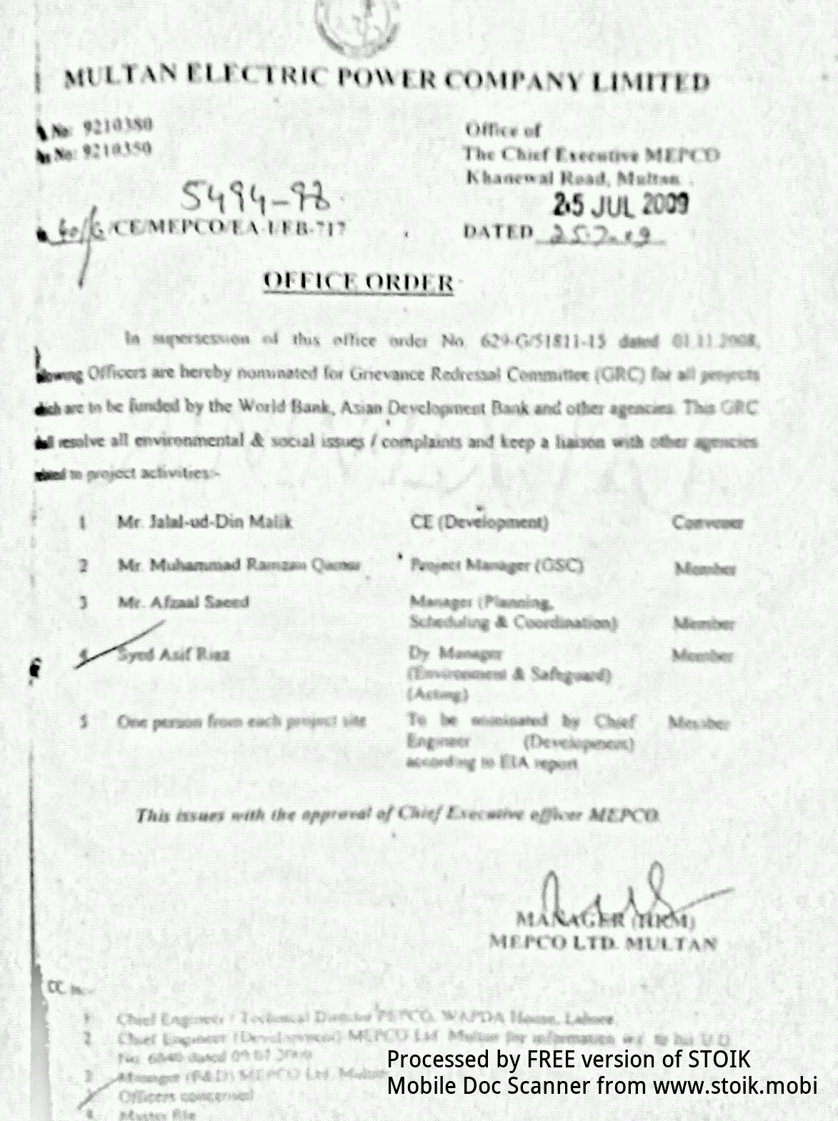

ANNEX [J]

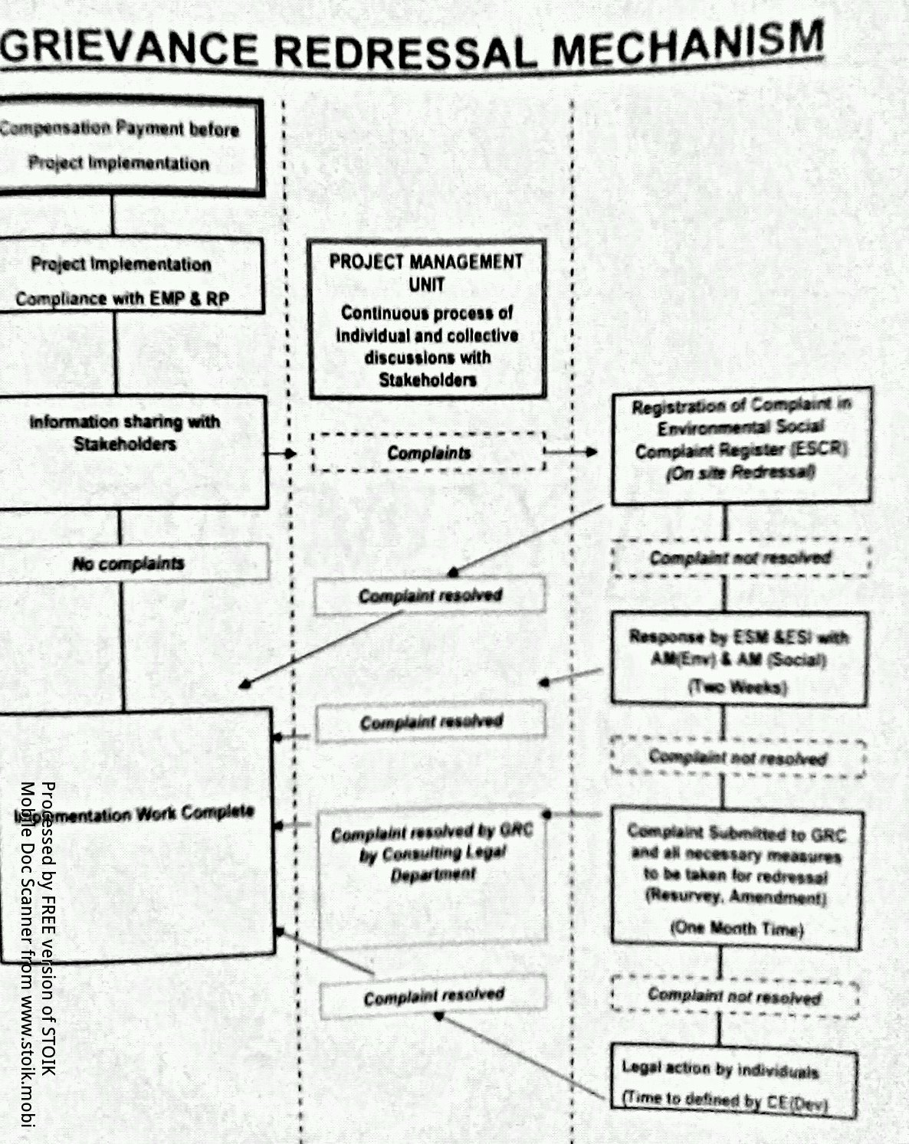

GRIEVANCE REDRESSAL MECHANISM
All stake holders, interested / affected persons and general public are notified that MEPCO Multan in Districts Multan, Bahawalpur, Bahwalnagar, Rahim Yar Khan, Lodhran, Pakpattan, Sahiwal, Vehari, Khanewal, Layyah, Rajan Pur, D.G Khan and Muzaffargarh is carrying out work of construction of new grid stations, extension, augmentation and conversion of grid stations in the Development Projects. All stake holders, interested / affected persons and general public are notified that if they have any kind of grievance related to the project work, they are requested to register their complaint along with their contact number in Environmental and Social Complaint Register which shall be already available at respected project site. Any action or mitigation measure shall be taken in minimum of 10 days and this would be informed to the complainant. For any further information, you can contact Environmental and Social Cell MEPCO.
1. Dy. Manager (Environment & Social Safeguard)
PMU MEPCO Ltd. Multan
Mobile: 0345-8189194
2. Assistant Manager (Social)
PMU MEPCO Ltd. Multan
Mobile: 0345-8189201

ANNEX [L]

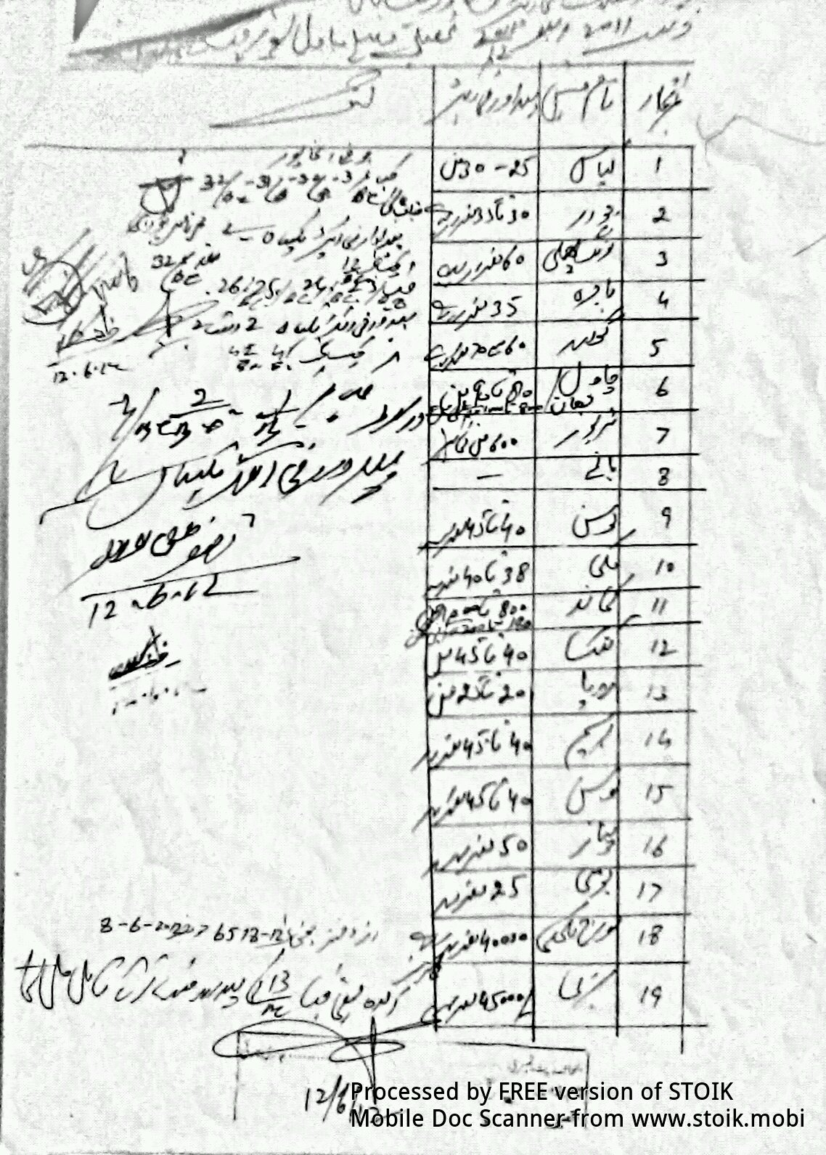

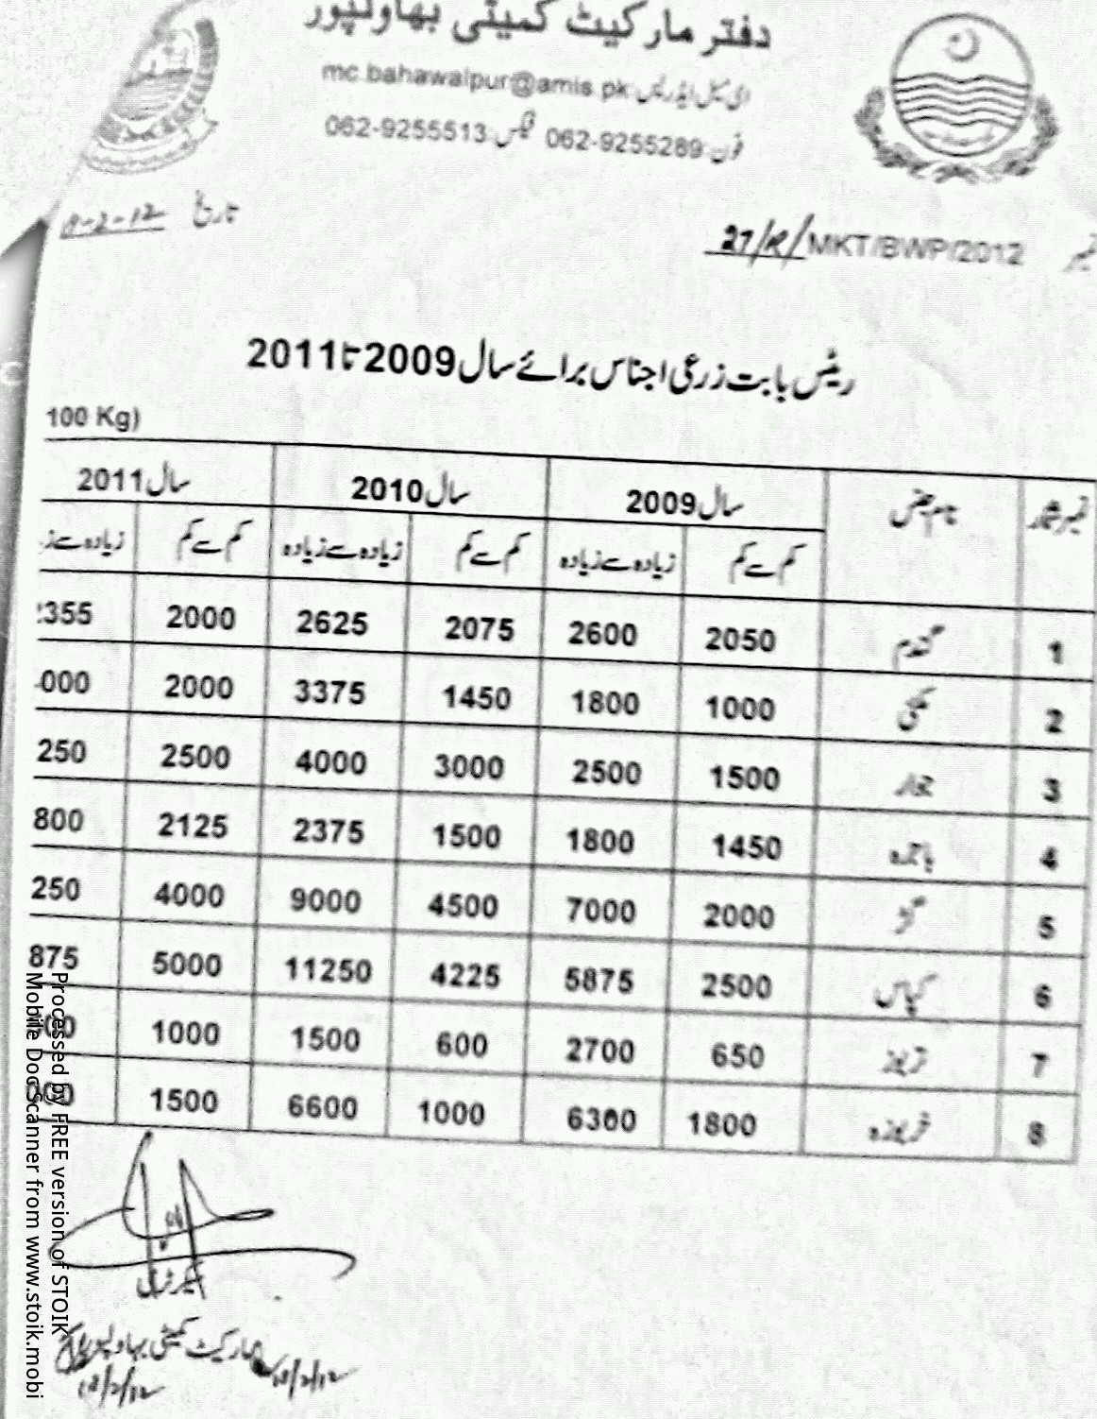

ANNEX [M]

Due Diligence Report
New Kameer 132kV Grid Station and Transmission Line Subproject

Background
- MEPCO is providing electricity to Arifwala and nearby villages from Arifwala 132 kV grid station. During the last few years, it is being observed that the local domestic, agricultural, commercial and industrial power demand of the area is increasing rapidly. Due to the increased power demand of the area, the power supply system has become insufficient and the existing grid station has become overloaded. So there is a need to improve the power supply system of the area. For the purpose, MEPCO has planned to construct the New Kameer 132kV grid station, near Tiba Sultan village. This grid station will be linked to the existing Yousafwala - Arifwala 132 kV transmission line by constructing a 60 m long transmission line. This Due Diligence report has been prepared for the same New Kameer 132 kV Grid Station and Transmission Line Subproject.

The Subproject
- This subproject will be constructed at Tiba Sultan village in Arifwala tehsil of Pakpatan district. This subproject involves the construction of 132kV grid station and a 60 m long 132kV double circuit transmission line. This is one of the subprojects included in Tranche 2 of the Program. MEPCO is in the process of purchasing land for the new grid station. The new grid station will be linked to the existing Yousafwala – Arifwala 132 KV double circuit transmission line. This transmission line is passing exactly over the selected grid station site, so only one new tower and a 60 m long line will need to be constructed. The new tower and the 60 m long transmission line will be constructed totally within the grid station site, without affecting any adjacent productive lands.

Subproject Impacts
- As stated above, this subproject consists of two components, namely new 132kV grid station and 132kV double circuit transmission line. The new 132kV grid station will be constructed on a plot of land measuring 49 kanals and 8 marlas (6.2 acres or 2.5 ha). MEPCO is in the process of purchasing this land directly from the land owner on a voluntary sale basis. There is one tube-well on this land, which is also included in sale deed, and MEPCO has agreed to pay its replacement value to the owner. So there is no involuntarily land accusation involved in the grid station. The transmission line consisting of only one tower and 60 m long power cables will be constructed within the boundaries ogf the grid station site, without affecting any of the adjacent productive lands with crops and trees. Except one tube-well, which is already included in the voluntary sale deed, there is neither any structure nor any crop or tree being affected by this subproject.

Purchase of Land for Grid Station
- MEPCO is purchasing a plot land measuring 49 kanals and 8 marlas (6.2 acre or 2.5 ha), on voluntary sale basis, from a landowner, Mr. Haji Akbar Ali son of Mr. Mansabdar Khan of Chak 26 EB, in Arifwala tehsil of Pakpatan district, for the New Kameer 132kV Grid Station at Tiba Sultan village. The prevailing open market rate of the area is Rs. 975,000 per acre, which has been agreed between MEPCO and the landowner and approved by the District Land Price Assessment Committee. Thus, the total price of the land, amounting at Rs. 5.99 million will be paid to the only landowner. In addition, the replacement cost of the tube-well has been assessed and agreed at open market value of Rs. 150,000. A contingency of 5% of the total compensation has been included in the cost estimate to cover taxes and other unseen costs which are estimated at Rs. 306,988.00 (see Table 1 below for details).

Table 1: Cost of Land Purchased for 132kv Kameer Grid Station Multan
No. | Description of Expenses | Amount (Rs.)
1 | Price of Land (@ Rs. 975,000 per Acre x 6.175 acres) | 5,989,750
2 | Replacement Cost of Tube Well | 150,000
3 | Total Compensation | 6,139,750
4 | Contingency (5 %) | 306,988
Total Resettlement Cost |  | 6,446,738
- An affidavit of sale deed has been signed by the landowner (see Appendix 1 for documents). The total land price will be paid to the landowner and the sale deed will be registered with the District Revenue Department before taking over the physical possession of the land by MEPCO.

Due Diligence
- According to the design whole activity of construction of the grid station and transmission line will be completed within the purchased site. There is no claim of any person on the land of this grid station. This grid will be fed by Yousafwala – Arifwala 132kV transmission line. This line is passing over the grid station site. To connect this grid station with the transmission line only one tower and a 60 meter line will be required and this line will be traversed within the grid site so this line will have no effect on any person at all. As there is no involuntary resettlement involved in this subproject and the preparation of a LARP for this subproject is not required, hence this brief Due Diligence Report has been prepared for the documentary requirements of both the MEPCO and ADB.

Community Consultations
- Two community consultation meetings were held at the subproject site. Both the meetings were held at Tiba Sultan village adjacent village to the grid station. One meeting was held with male group and one with female group. Total participants in these two meetings were fifteen and all the participants were of the view that this subproject was important and much needed under the current circumstances. People are pleased by the project and they supported this subproject. None of the community members opposed the subproject.
- The local communities’ response (awareness, perceptions and preferences) for the Kameer grid station subproject and resettlement related matters are summarized as follows:
- This subproject is necessary under the current local conditions keeping in view the power shortage of the area ;
- Constructor should hire local labour if needed.
- Contractor should respect the local norms; and,
- Construction work should be completed in time.

ANNEX [N]

Appendix 1: Documents of Purchase of Land for New Kameer 132kV Grid Station
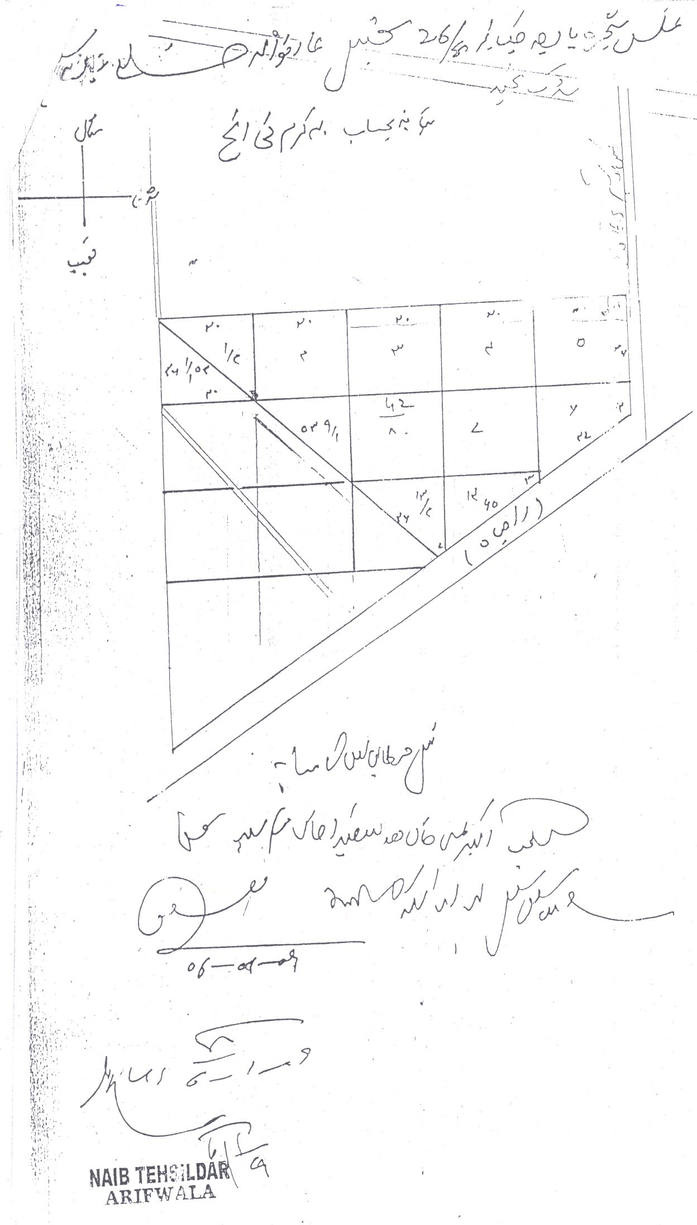
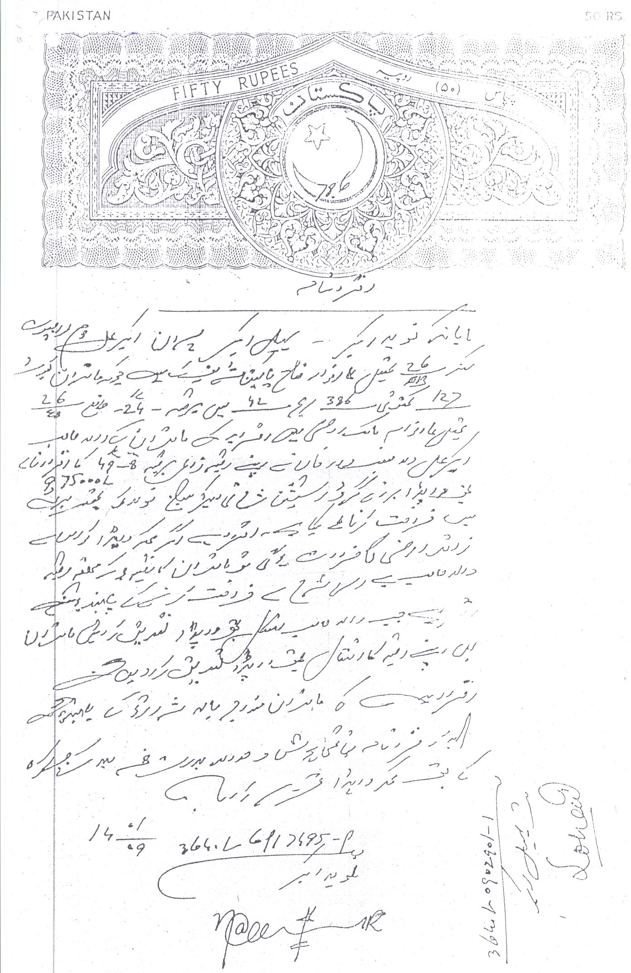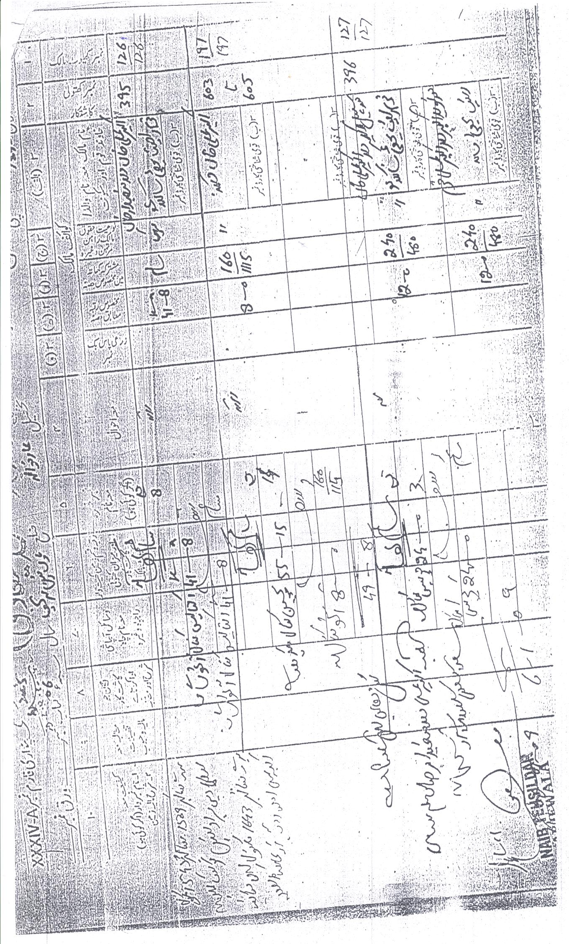

Kanal is a local land measuring unit (1.0 ha = 19.77 kanals; 1.0 Acre = 8.0 kanals).
There are twenty Marlas in a Kanal (1.0 ha = 395.4 Marlas).

